Electronic mask
for lucid dreaming
«AstroLine»

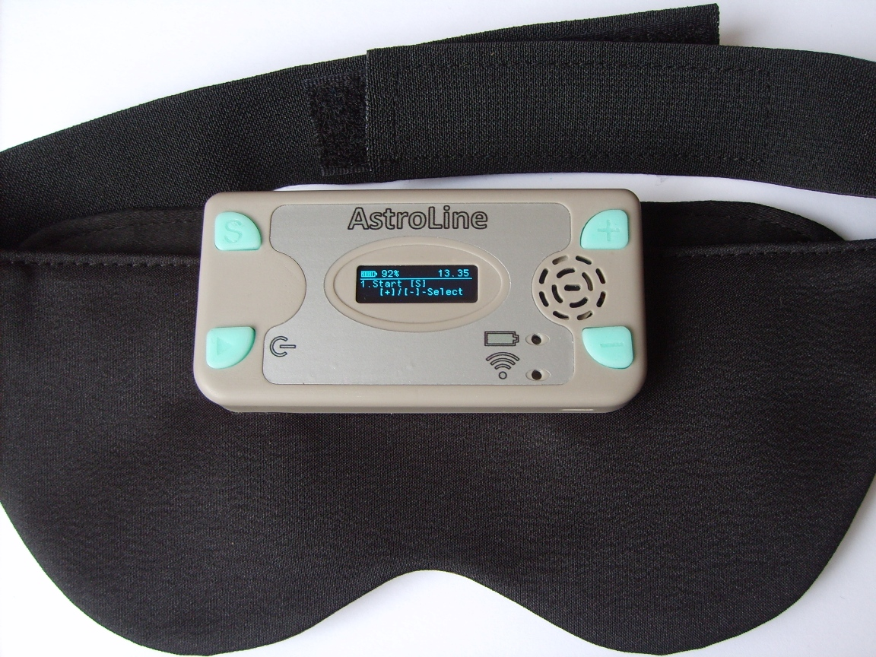

Technical description
and operating instructions

_____________________________________________________

2021
CONTENTS

1. PREFACE
1.1 General description .......................................................................... 3
1.2 Operating modes of the device ...................................................... 5
1.3 Recommendations for working with the device
1.3.1 Beginning of work ............................................................................ 7
1.3.2 Organization of data on the memory card ................................... 8
1.3.3 Battery charge control ...................................................................... 8
1.4 Set ........................................................................................................ 9
1.5 Specifications ..................................................................................... 9
1.5.1 Equipment composition and characteristics.................................. 9
1.5.2 Operating modes «AstroLine»........................................................ 10
1.5.3 Weight and dimensions .................................................................. 10
1.5.4 The consumed current from the battery....................................... 11
1.5.5 Operational requirements ............................................................... 11

2. HOW TO WORK WITH THE DEVICE
2.1 General ………………………..................................................... 12
2.2 Appearance, controls and connectors .......................................... 12
2.3 The procedure for connecting and disconnecting
external devices when working with the device.......................... 14

3. EMBEDDED SOFTWARE ver. 1.3
3.1 General. Main menu ........................................................................ 15
3.2 Overview of main menu items and operating modes
Start .................................................................................................... 16
Settings .............................................................................................. 16
Test .................................................................................................... 19
Time set ............................................................................................. 20
Sleep timer ........................................................................................ 20
End time of sleep ………………................................................. 20
Light prompts ………………….................................................. 20
Recording folder .............................................................................. 21
Record ............................................................................................... 21
Play folder .................................................................................. ...... 22
Player.................................................................................................. 22
Wi-Fi .................................................................................................. 22
3.3 WEB-interface .................................................................................. 22
Software update ……………...……………………………... 26

4. OPERATION IN USB STORAGE MODE ......................... 26

5. CHARGING THE STORAGE BATTERY .......................... 27

Attachment 1
LOG file form and sleep event analysis ........................................ 27

Annotation

This document contains a description of the AstroLine lucid dreaming device and how to operate it in different modes.
To understand what «lucid dreaming» is and to get methods of working with them, we recommend the book by Stephen LaBerge «Lucid Dreaming».

- PREFACE
  - General description
The device for lucid dreaming AstroLine (hereinafter «AstroLine») is an electronic device attached to a head mask made of opaque black material, which also houses a board with eye movement sensors and LEDs for issuing light prompts.
«AstroLine» differs from previously produced devices for lucid dreaming in the following advantages:

Construction of the mask:
  - the device is mounted outside (forehead), and not inside the mask itself, which makes it easy to control the device and select the desired operating mode using the keys and display, does not give a tangible load on the face, distributing it on the forehead.
  - the mask does not touch the eyes and face, does not interfere with falling asleep.
  - when the mask is put on, then in the waking state, lowering its eyes, it allows you to see objects and adjust modes using a tablet or smartphone, selecting the optimal effect of light and sound.
  - the mask consists of a base (mask), two fasteners and a forehead pad over these elements. The head cover is the single most contaminated part and can be easily removed and washed. The device itself, together with the eye movement sensor board, can also be removed from the mask, if necessary, and the mask washed and ironed.
  - dividing the product into functional units «device» and «board with sensors» allows you to replace the board with sensors in the future, installing various special versions, for example, for taking EEG (electroencephalogram) with a corresponding headband.

Functional of the electronic part:
  - the presence of a display and keys allows you to independently configure the device and turn it on without any additional devices.
  - in addition, the device has a WEB-interface, accessible by connecting to it as to a Wi-Fi access point from any device (smartphone, computer or tablet), upon activation of the corresponding function. In this mode, it is also possible to download a firmware update for the instrument.
  - eye movement sensors are placed on each eye. This allows you to more fully track the sleep pattern, since not always in the REM (rapid eye movement) phase, both eyes move simultaneously.
  - full-color RGB LEDs are used for issuing light tips, allowing you to set the color of the light tip and thereby reduce the addiction to one color. In addition, this solution allows the mask to be used in other applications - playback of audio-visual sessions for falling asleep or audio recordings made using AudioStrobe® technology with a strobe signal frequency of 19200 Hz. *
  - play WAV and MP3 audio files before bedtime (as relaxation music) and after bedtime ends (Alarm clock).
  - dictaphone with high sound quality (16 bit) and the ability to record, listen and delete records in the device itself. Recordings are formed as WAV files and are ready to be directly played as prompts, before and after highlights.
  - real time clock. They allow you to set the usual time in the device and record all events (start of sleep, triggering of sensors, end of sleep or interruption of monitoring), with reference to this time. Events are displayed and recorded in special LOG files, which can then be easily viewed with a regular text editor or processed by drawing up a sleep diagram.
  - the device has a head movement sensor (accelerometer) with an adjustable response threshold. Information about head movement is not only noted in the events of the LOG file, but also allows, with appropriate setting, to interrupt the issuance of prompts from the device. This information also makes it possible to distinguish between triggering when the mask is accidentally displaced in front of the eyes during head movement and eye movement during sleep.
  - the ability to work as a USB drive when connected to a computer via a USB cable, which allows you to quickly view LOG files about a past dream, as well as download or delete music files and voice prompts.
  - there is an LED indication of the operation of the Wi-Fi access point or the mode of replacing the firmware, as well as the operation of the charger. During operation (during monitoring or when playing music and prompts), the indication is made by backlighting the «Enter/Start» button.
  - all files for the device operation are located on a microSD memory card, which is installed on top of the device and is easily accessible. However, the device can work without a memory card, respectively, events during sleep will not be recorded in LOG files, as well as voice prompts and music will be recorded and played.
  - for sound output there is a built-in speaker and a 3.5 mm stereo audio jack, when headphones are connected to which the speaker is disabled. The mask has loops on the headband through which the headphone wire can be put on so that it does not fall on the face.
  - there is also a vibrating call with adjustable intensity, used to issue a prompt in sync with the light.
  - the device contains a Li-Pol (lithium polymer) battery with a capacity of 800 mAh and a built-in charger from a USB socket.
  - automatic shutdown of the device is provided: when it is in the settings mode and there is no action for more than a specified time, when sleep and monitoring mode are completed, and when the audio recording is stopped. This function allows you to significantly save battery power when the device is used during settings and testing. In the off state, the device does not consume current from the battery, only the real time clock works.
* work with sessions and strobe tracks is available in special firmware versions.

Software:
Software replacement is provided by downloading a binary file with a new version via the web interface. For menus and labels in the web interface, the language can be selected: Russian or English. The software defines all the device functions available to the user. When creating it 3 main tasks were set:
- make the most simple, intuitive interface, not overloaded with unnecessary functions and settings.
- realize the maximum capabilities of this device in its logic of operation.
- leave a reserve for expanding the software functionality of the device.
What will it be like in the future? Perhaps you yourself can answer this question and give a useful idea.

  - Operating modes of the device
AstroLine has the following operating modes:

Sleep monitoring
This is the main operating mode of the device. When this mode is enabled, then after the music playback is finished (if it was turned on) and the countdown until falling asleep starts monitoring the sensors.
At the same time, if a MicroSD memory card is installed, then information about the triggering of sensors is recorded as a LOG file with a number corresponding to the internal indexing, which will increase by 1 for each new monitoring.
If the playback of prompts (light and/or voice) is allowed, they will be played when the eye movement sensors are triggered, taking into account the set delay. First of all, a voice prompt from the BEFORE folder is issued, then a light and vibro-prompt (it stimulates easy awakening and perception), and then a voice prompt from the DICT folder. If the head movement prompts are turned on, the prompts will turn off when the head moves. The volume levels when issuing voice prompts from the BEFORE and DICT folders can be different.
Sleep monitoring can be interrupted by pressing any button on the device or at the end of the set sleep time. In the latter case, if the Alarm is enabled, the file for the Alarm will be played. After sleep monitoring is completed, the LOG file will be closed with the end time assigned (from the real time clock). If sleep monitoring was completed before the sleep timer expired, the LOG file will not be created.

Record from the built-in microphone and listen or delete voice prompts
Allows you to record voice guidance in WAV file format. The file name is an index that increases by 1 with each new record. Files can be immediately selected for listening or deleting (if not needed). Also, in the voice recorder mode, you can set the maximum time for recording a hint in minutes, after which the recording will be closed.
When the eye movement sensors are triggered, the tips will be played back in the order of their recording, after the delay set in the settings. In the same order they can be viewed (scrolled) in the voice recorder playback or delete mode. The folder with which the voice recorder works can be changed.

Play audio files from a folder designed to store music and play before going to sleep in the PLAYER mode
This mode is needed for preliminary listening to music that will be played before falling asleep. It can also be used as a regular MP3/WAV player. In the player mode, you can play music from both the main folder, and listen to the recordings intended for playback in the Alarm mode, depending on the folder set for the Player.

Play music from the folder for storing alarm recordings after sleep
Switching to it is possible only when the monitoring is completed at the set sleep end time, while the Alarm clock was enabled and the MicroSD card was installed, and there are WAV or MP3 files in the corresponding folder for the Alarm clock. Files are played one after another until the end (while they are in the folder), or when the playback is interrupted by the user (pressing the keys).

Work in the mode of setting various parameters directly on the device
The device configures a lot of basic and auxiliary parameters that allow you to set the optimal sleep monitoring mode and prompts. They can be selected among the main menu items in the device, among the «Settings» menu items, as well as through the WEB interface, when the device is connected to an external device via Wi-Fi. If the device is in the state of selecting a setting or changing parameters for a long time and no action occurs, but the power off timer is enabled, the device will be turned off after the specified time.

Working in web-interface mode via Wi-Fi
This mode provides communication between the user's device (computer, tablet or smartphone) and «AstroLine». Through it, it is possible to change a number of device settings, as well as load a new version of the firmware into the device itself. In addition, from this mode, you can test the operation of vibrating, light and voice prompts when the mask is already on the head. And also change the internal recording indices of the voice recorder files and LOG files (this cannot be done on the device itself).

Checking the operation of the device (test sensors and prompts)
It is possible to start a full test of the device operation, as if it were in the monitoring mode. This is where the eye movement sensors and the head movement sensor are tested. The triggering results are firstly displayed on the display. Second, they lead to prompts. This allows you to select both the sensitivity of the sensors and the required delay intervals in prompting and monitoring, as well as the volume and brightness levels of prompts. In addition, determine the optimal position of the mask on the head when the sensors are working.

Working in USB storage mode
Designed for navigation and work with the contents of the microSD memory card installed in the device. The mode is activated by connecting the device to a computer via a USB cable and turning on the power. In this case, a memory card must already be inserted.

Battery charge
To charge the battery, it is enough to connect the charger or USB cable from a running computer to the device. The power supply should not be switched on.

  - Recommendations for working with the device
    - Beginning of work
It is better to start working with the device with simple monitoring without prompting. In this case, the sensitivity of the sensor should be sufficiently high (value about 30), and the interval between monitoring phases should be small (1-3 minutes). In this case, it will be possible to see the complete picture of your sleep and determine the sensitivity thresholds of the sensors. Such work on removing the «picture» of sleep can be carried out within 2-3 days.
At the next stage, you can already turn on light/voice prompts and vibration. It is necessary to start with the minimum values ​​of brightness and loudness audible in the mode of checking. Disable vibration if you want to see movement in a dream among the events of the LOG file (activated vibration automatically turns off the head movement sensor, since the sensor is in the device itself !). This is important because the selected high light intensities or the volume of the voice prompts can completely awaken you. The dream is then fragmented and unhealthy. In this case, you need to reduce the brightness and volume levels to reduce the number of recorded movements.
One of the recommendations for using the device is the preliminary development of regular sleep, when the sleep phases occur at approximately the same time of day. But, if you have sleep disorders or insomnia, the device is not recommended to use.
The mask is designed to sleep on either side or back. It is not recommended to cover yourself with your head or put your hands on your head (mask), since pressing the button during sleep monitoring interrupts work and after a while the device turns off.
To work effectively with the device and to exclude missed alarms or false alarms, it is best to turn it on in the test mode when the mask is on the head. The position of the sensors and LEDs in front of your eyes will be visible. It is also worth making sure that nothing interferes with the operation of the device (hair, clothes).

    - Organization of data on the memory card
To fully work with the device, it is important to know what information is on the memory card and in what folders.
The folder structure is shown in Figure 1.
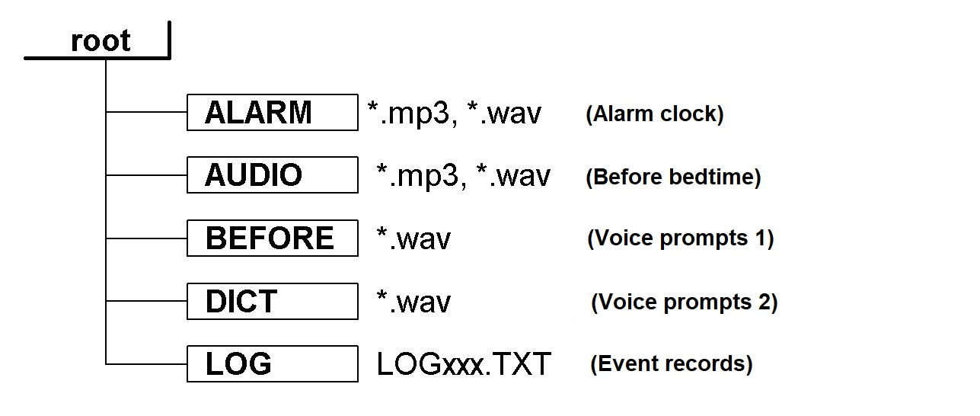
Figure 1. Folder structure on the memory card

The device is delivered with a memory card, on which the designated folders are already present, and test records are recorded in the ALARM and AUDIO folders. You need to write your files to these folders. Voice prompts are created when recording from a voice recorder. LOG files are created during monitoring.
If a new (blank) memory card is installed, then the folder structure shown in Figure 1 will be created on it automatically.
It is important to note that the memory card must be pre-formatted with the following parameters:
- type of file system FAT32
- standard cluster size (512 bytes).
Otherwise, work with the memory card will be impossible.

    - Battery charge control
Before starting monitoring mode, it is important to pay attention to the battery charge. This value is displayed in the header of the main menu of the device next to the battery icon.
If the charge level is below 30%, it is not recommended to start monitoring mode. It is also not recommended to start replacing the firmware on a low battery charge (20% or less).
Switching off the device at the time of software update may lead to the loss of its performance, which can only be restored by sending it to the manufacturer for repair.

  - Set
The «AstroLine» delivery set includes the following devices and accessories:
- «AstroLine» device with an eye movement sensor board.
- Mask with a forehead pad.
- AC adapter/charger.
- USB cable.
- MicroSD memory card with a capacity of 8 GB.
- Paper copy of this manual and annex (if available in the current version).
- Packing box.

  - Specifications
«AstroLine» is designed to determine the sleep phase by eye movement, generate a time report about these events, move in sleep and play back light and sound prompts, WAV and MP3 audio files. It is also designed to perform a number of service and auxiliary functions both in stand-alone operation and when working with a computer.
The device complies with technical conditions 262016-002-79494790-2020.

    - Equipment composition and characteristics
  - Microcontroller – 32 bit, ARM Cortex-M3 architecture;
  - Measurement of small movements (eye movement) using two IR sensors located on the external board;
  - Motion detection using the built-in accelerometer, sensitivity resolution no worse than 0.03g;
  - Built-in wireless Wi-Fi interface (IEEE 802.11g);
  - Real time clock/timer, measurement and formation of time intervals;
  - 16-bit audio digital-to-analog converter (DAC)/analog-to-digital converter (ADC) with digital sound processing unit;
  - Communication interface with a personal computer – USB 2.0, mini USB connector;
  - Slot for inserting microSD memory cards, including support for SDHC memory cards. File system type for memory cards – FAT32;
  - Audio output for connecting headphones:
- 3.5 mm «mini-jack» (1/4" TRS mini);
- permissible resistance of the connected load - not less than 32 Ohm;
  - Built-in short-range microphone for recording voice messages to a memory card;
  - Built-in speaker for playing messages or audio files;
  - Play MP3 and WAV audio files;
  - Indicator LEDs:
- indication of the battery charging process (red / green),
- indication of the Wi-Fi interface operating mode (red / green),
- indication of sleep monitoring mode, playback of audio files, sleep timer operation (green in the backlight of the «Enter/Start» button);
  - Image – monochrome graphic display (OLED technology) with a resolution of 128x32 pixels;
  - Input – 4 tact buttons, including a combined «Enter/Start» button with power on/off;
  - Two 24-bit RGB LEDs located on the eye movement sensor board. The addressing and setting of each LED is individual. The interface is serial, single-wire.
  - Maximum LED brightness:
- red spectrum (wavelength 620-630 nm) 500-600 mcd,
- green spectrum (wavelength 515-530 nm) 900-1100 mcd,
- blue spectrum (wavelength 465-475 nm) 200-400 mcd;
  - Slot for installing the sensor board on the device: eight-pin, for a flat cable/board of the FB-8R type;
  - Battery Li-Pol, 800mA/h;
  - Built-in battery charger from USB socket with a charge current of no more than 300mA;
  - Firmware update: download the binary file via the web-interface (when establishing a Wi-Fi connection).

    - Operating modes «AstroLine»
  - Sleep monitoring.
  - Record from the built-in microphone and listen or delete voice prompts.
  - Play audio files in the PLAYER mode.
  - Play music from the folder designed to store the Alarm recordings after sleep.
  - Work in the mode of setting various parameters directly on the device.
  - Work in web-interface mode via Wi-Fi to manage settings and replace firmware.
  - Checking the operation of the device (test sensors and issuing prompts).
  - Work in USB storage mode.
  - Battery charge.

    - Weight and dimensions
«AstroLine» measures 90.5x45x15 mm, taking into account the protruding parts (buttons, fasteners to the mask) and without an installed microSD memory card.
The weight of the assembled product and its individual parts is shown in Table 1.1.

Product | Weight not more than (g)
Device without mask | 50
Device with mask, sensor board and cover plate | 84
Sensor board | 2
Table 1.1. Weight and dimensions of the «AstroLine»

    - The consumed current from the battery
The current consumed by the device differs depending on the operating mode. You need to know this when starting certain modes on the device, taking into account the current battery charge level.
The data on the consumed current are given in Table 1.2.

Mode | Current consumption no more (mA)
Work in the settings menu, playback of melodies by the player at medium volume | 50
Recording messages from the microphone | 45
Monitoring mode when prompts are turned on at medium brightness and volume values | 22
Working with the web-based interface (Wi-Fi enabled) | 110
Firmware update inside the device (Wi-Fi disabled) | 40

Table 1.2. Consumption current «AstroLine» in different modes

In the process of improving the firmware, work is underway to reduce the current consumption in various modes, therefore, for new versions of the firmware, the data may change.

    - Operational requirements
«AstroLine» together with accessories in accordance with the state standard 15150-69 refer to products of the placement category – 4 for climatic performance – moderate and cold climate, with a range of operating temperatures from +1 to + 40°C and is intended for operation in heated indoor premises.

Not allowed during operation:
- place the device near heat sources and open flames;
- wipe the case, display screen, keyboard buttons with organic solvents and other cleaning agents that are aggressive to plastic;
- create mechanical pressure in the display area;
- use other types of power adapters (chargers) instead of those recommended by the manufacturer or supplied with the device;
- connect and disconnect the sensor board during device operation;
- remove the sensor board and place it on surfaces that can accumulate static electricity;
- replacing the microSD memory card with the device turned on;
- static electricity hitting the device connectors;
- using the device in rooms with a relative humidity of more than 80% and storage in damp rooms;
- connecting headphones with a load impedance of less than 32 Ohm to the audio jack, as well as applying considerable force to this jack when inserting the plug;
- turning off the power supply of the device during the replacement (programming) of the firmware;
- wash the mask and pad at a water temperature of more than + 40°C;
- iron the mask with an iron at temperatures over + 80°С.

2. HOW TO WORK WITH THE DEVICE

  - General
Before working with the device, you must read this manual.
Upon receipt of the device, it is necessary to check its completeness and safety after transportation, the absence of damage to the container. If the device is moved from a cold (temperature below 0ºC) to a warm room, then before switching it on, leave it at this temperature for 20-30 minutes.
The device is delivered with a battery installed in it. During storage, due to self-discharge, it can be partially discharged. It is necessary to pay attention to the charge level after switching on.
It is displayed in% near the battery icon in the upper left corner of the main menu. If the level is 40% or less, then it is necessary to charge the battery in accordance with paragraph 5.

  - Appearance, controls and connectors
Figure 2 shows the external view of the device and gives callouts with the designation of connectors, indications and keys.
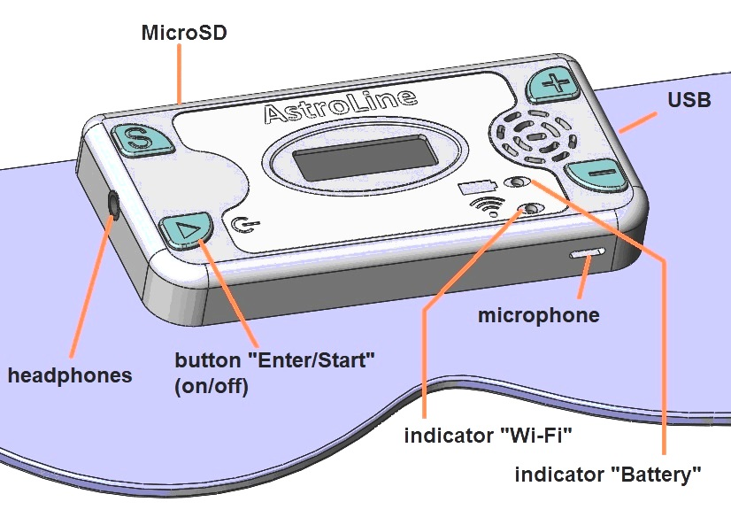

Figure 2. View of the device on the mask

Connectors, controls, indication

Headphones. The device has a 3.5mm Jack socket for connecting headphones. Allows connection of headphones with a total impedance of at least 32 Ohm. The built-in speaker is disabled when headphones are connected. On the strap of the mask on the side of the headphone jack, there are loops through which you can thread the wire so that it does not fall off your face.
USB. The device also has a USB connector for connecting a charger or for connecting to a computer. A 5-pin miniUSB connector is used. This interface is used to copy/delete files on a memory card and view LOG files (Mass Storage Device mode).
MicroSD. On the top of the device there is a slot for a microSD memory card of the «push-push» type (push to insert the memory card and push to eject).
Microphone. The opening of the housing, opposite which the microphone is located, faces down the mask. Voice messages for prompts are recorded from a short distance (about 20 cm to the microphone).
On the front side of the device there is a built-in speaker, display, indicator LEDs and control buttons.
Indicator «Wi-Fi» and «Battery». The LEDs are bi-color. During basic Wi-Fi operation, the indicator is mostly red. When preparing files for firmware update - blinks green, during programming - blinks red. When the charger is working, the battery indicator glows red, after the end of the charge it glows green (when the device is turned off).
Button «Enter/Start» (hereinafter «Enter»). It is multifunctional. When pressed for a long time, this button turns on or off the power (from the main menu or during Wi-Fi operation).
With a short press in the mode of changing settings, it confirms the change and sets the value, saving it to non-volatile memory. When pressed in the playback file selection mode (in the PLAYER or RECORD menu), it starts the file playback.
If the button is pressed during the playback of voice guidance by the player / recorder or playback of an audio file, this playback stops and the button is highlighted in green. Pressing again - continues playing the file. In addition, this button is illuminated (blinking) in sleep monitoring mode, while counting intervals of delays and sensor operation, or when playing prompts and audio files. This backlight allows you to judge the active operation of the device, including when the display is turned off (turned off) in the sleep monitoring mode.
Button «S» (Select). When working in the main menu, the button enters the selected item of the main menu (starts the operation). When working in settings modes, this button selects the desired setting or is a function key (modifying the operation of the «+» and «–» buttons). When playing an audio file, this button interrupts playback and switches to the menu (when the PLAYER or RECORD is running).
Button «+» and «–». When working in the main menu, the buttons change the main menu item, and when working in the settings, they change the setting. In the PLAYER or RECORD these buttons change the file to be played or deleted. When playing an audio file, these buttons change the playback volume (the setting is saved directly to energy independent memory).

  - The procedure for connecting and disconnecting external devices when working with the device
While working with the device, it is necessary to follow the order of connecting some devices in order to avoid damage to both the device and the devices themselves.
Headphones. They can be connected and disconnected at any time during the operation of the device. When headphones are connected – the speaker is disabled.
Memory card. It is allowed to remove and install only when the device is switched off.
AC adapter. It is allowed to disconnect and reconnect it at any time. It is necessary to connect the adapter when the charge level drops below 30% (displayed in the main menu in the upper left corner).
Work with USB in removable storage mode. The USB cable is connected to the device and the computer when the device is turned off. Switching on the device (with inserted memory card) activates the mode of operation as a USB removable data carrier.
Turn on/off the device. It is allowed to produce at any time except for:
- process of copying files via the USB-interface,
- process of replacing the firmware.
In these cases, in the event of an abnormal shutdown, the data will be lost, and in the latter case, the performance of the device may be impaired.

3. EMBEDDED SOFTWARE
VER. 1.3

  - General. Main menu
All functions and available capabilities of the device are determined by the firmware version. Therefore, the description of the AstroLine operation is related to the current version of the firmware. It is necessary to check the software version specified in this manual and the version recorded in the device. You can read this version through the web interface (indicated at the bottom of the page).
After turning on the device with the «Enter» button (on), you go to the main menu. Before that, the presence of a memory card is checked (if it is absent, a message is displayed about the absence of a memory card). If there are no folders required for operation on the memory card (see Figure 1), then these folders are created. The state of the settings stored in the energy independent memory is also checked.
If a failure (loss of settings) is detected, they are set by default, and the RTC Config… message will appear on the screen, after which you will go to the main menu.
Figure 3 shows the view of the main menu of the device.

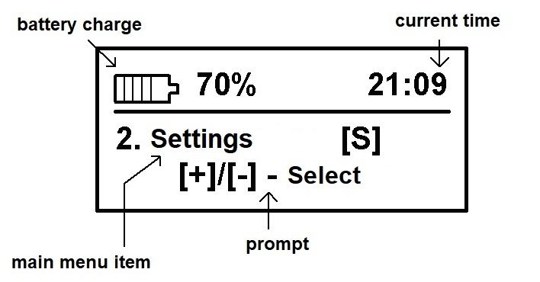

Figure 3. Main menu of the device

The main difference between the main menu and others is navigation through its items. It is made only with the «+» and «–» buttons, and the selection of a menu item – with the «S» buttons.
At the same time, the «Enter» button works as a power off button when pressed for a long time and does not perform any other actions when working in the main menu. The screen, in addition to the main menu item, also displays the battery status and current time.
  - Overview of main menu items and operating modes

Start
Selecting this item starts sleep monitoring mode. If at the same time playback of melodies is allowed in the settings, a MicroSD memory card is installed and the files are in the AUDIO folder, then after the countdown of the 20 second interval (time for preparing and putting on the mask), they begin to play until they run out. During melody playback use the «+» and «–» buttons to change the sound volume. Pressing the «S» or «Enter» button interrupts playback and returns to the main menu. When the audio files in the AUDIO folder have finished playing, the sleep timer starts.
--------------------------------------------------------------------------------------------------------
Important! In the AUDIO folder, you should place melodies that make it easy to fall asleep or set you to sleep. At the same time, their playback time has nothing to do with the set time for the sleep timer. And in fact, the time before the start of monitoring will be determined by the playback time of audio files from the AUDIO folder and the time set for the sleep timer. It is necessary to consider this point when choosing the number and duration of audio files and the time to fall asleep.
--------------------------------------------------------------------------------------------------------
During the ringtone playback before sleep monitoring and after the first 5 minutes of the sleep timer, the display screen dims to save battery power. The activity of the device can be seen by the blinking backlight of the «Enter» button. If the blinking of this indicator interferes with falling asleep, then it can be turned off through the setting in the web interface.
The time for the sleep timer is set by the SLEEP TMR menu item.
After the sleep timer expires, sleep monitoring begins with recording events in the LOG file. If hints are enabled in the settings, they will be played. Light and vibration prompts are played first (if enabled), followed by a voice prompt (if enabled and recorded in the DICT folder). After that, the scan delay begins and then - the interrogation of the eye movement sensors.
If prompts are interrupted by head movement, a corresponding entry is made in the LOG file. Sleep monitoring continues until the set sleep end time (menu item END TIME). Pressing any key during sleep monitoring or counting time intervals and playing prompts will terminate monitoring, close the LOG file and exit to the main menu.
The end of sleep monitoring and its time is also recorded in the LOG file as well as the reason why it ended. If this record is not present, your device turned off during monitoring due to a discharged battery.

Settings
Selecting this menu item leads to the transition to the settings editing mode. The setting is selected with the «S» button, and its change with the «+» and «–» buttons.
Pressing the «Enter» key ends the settings editing mode and switches to the main menu.
It should be noted that the saving of the setting in the energy-independent memory occurs always after its change.
There are 14 items in the setup menu. Let's consider each of them:
- Language
Sets the interface language. The choice is [Rus] – Russian language, [Eng] – English. Immediately, after changing this setting, pressing the «S» or «Enter» buttons will go to the main menu, where the entire display will be in the selected language.
To continue editing the settings, select this item in the main menu again. The second feature of this setting is that the value set here sets the display language for the web interface. The device page will be displayed in Russian or English, depending on the value set here.
- Sensitivity
Sets the sensitivity of the eye movement sensor. It can vary from 1 to 99. A small value corresponds to the maximum sensitivity, and a large value to the minimum. The average value (by default) is 30. The eye movement sensor can be tested by selecting the TEST item in the main menu.
- Scan time
The parameter defines the scanning time interval – 5 ms (milliseconds). The range of change is from 1 to 9. Accordingly, the value «1» is 5 ms, the value «3» is 15 ms, etc. This parameter determines the recorded speed of movement of the eyelids during REM. The recommended average value is «3» (set by default). The larger this parameter, the slower eyelid movements will be visible to the sensors.
- Motion Det.
This setting sets the sensitivity of the head movement sensor and can be in the range from 0 to 9. The minimum value «0» corresponds to the maximum sensitivity to movements, the maximum value – the minimum sensitivity. The motion detector always works in monitoring mode.
- Motion stop Off
Interruption of head movement prompts. The setting is [On] – enabled and [Off] – disabled. If there is a value corresponding to «On», then when the head moves at the time the prompt is issued, this prompt will be immediately interrupted. This setting does not work (equivalent to «Off») if the vibrating alert is enabled for prompting.
- Vibro volume
The setting enables and sets the vibration intensity when prompting. It can take a value from 0 to 9. The value «0» corresponds to off vibration. The minimum value corresponds to a low vibration level, a value of 9 – to the maximum. The default is «3» (optimal). Vibration is generated synchronously with the light prompt.
- Sound volume
This setting sets the sound volume when playing voice prompts (from the DICT folder) and playing audio files before falling asleep (from the AUDIO folder). It can range from 0 (soundless) to 30 (maximum volume).
- Scan delay
The setting sets the delay time in minutes between the triggering of the eye movement sensor with prompts and the start of the next scan. Accepts a value from 0 to 45. If the value is «0» – there is no delay and scanning starts immediately after the prompt is issued.
- Prompter On
Turns light and vibration prompts on or off. The setting is [On] – enabled and [Off] – disabled. If the value is «Off», then light and vibration prompts are not issued regardless of the values set there.
- VOX_prompt On
The parameter enables or disables the issuance of voice prompts. Works regardless of the setting of the previous parameter (prompts by light and vibro). The setting is [On] – enabled and [Off] – disabled. If voice prompts are turned on, while a MicroSD memory card is installed in the device, and voice prompts are recorded in the BEFORE and DICT directories, they will be issued when the eye movement sensor is triggered during sleep monitoring. First, a voice prompt is issued from the BEFORE folder, then – light and vibration, after that a voice prompt is issued from the DICT folder.
The prompts are issued in the order of their formation (recording): when the sensor is first triggered, the first prompt from the folder is displayed, during the second – the second, and so on until the end. If the tips run out in the folder, the first tip will be displayed again, and so on in a loop. If only one voice prompt is recorded in the DICT or BEFORE folders, then it will always be issued when the sensors are triggered.
- VOX_P. Delay
This setting determines the delay time in seconds between the activation of the light and vibration prompts and the issuance of a voice message, if its issuance is allowed. Accepts a value from 0 to 99. The parameter affects the perception of the voice prompt. If you see lights in a dream, then at first you do not understand what it is, it takes time to perceive the voice. And only after a few preset seconds you hear a voice. When set to «0», there is no delay and the voice plays immediately after the light. A small value between 2 and 10 seconds is recommended. The default is 3 seconds.
- Time_OFF
Sets the time for the off timer in minutes. Accepts a value from 0 to 15. When the value is set to «0», there is no auto power off, the device works constantly (not recommended). The default is 5 minutes. The timer is triggered when you forgot the device while editing the settings or stopped the player or performed any other action that leads to the expectation of further actions from you, but they do not happen. The auto-off timer is deactivated when working in sleep monitoring, as well as when the Wi-Fi interface is started.
- ALARM volume
This setting specifies the volume with which the audio file from the ALARM folder will be played back after monitoring by the end of sleep time (this is the Alarm mode). The sound volume can take a value from 1 to 30. The default value is 21. When the value is «0», the alarm clock is turned off and after the sleep monitoring is completed, you exit to the main menu without playing files from the ALARM folder.
- BEFORE volume
This setting determines the volume of the voice guidance from the BEFORE folder. It is generally recommended that this prompt be heard at a lower volume than that after the light prompt. The volume can range from 1 to 30, just like other volume settings.
- Tune
Enables or disables playback of tunes before falling asleep from the AUDIO folder. The setting is [On] – enabled and [Off] – disabled. If this mode is enabled and there is a memory card, and there are corresponding files in the AUDIO folder, then when monitoring starts from the main menu, the message Tune_ON will appear and the countdown will begin for 20 seconds (preparation time), after which music will be played.
- Reset settings
Allows you to return all settings to the «default» state, i.e. to some parameters set by the manufacturer. In addition, the values of the index counters for the voice recorder and the LOG file will be set to «000».
When this item is selected, if you press the «Enter» button, then only in this case a reset will be performed and an automatic transition to the main menu will occur.
If you press the «+» or «S» buttons, you will go to the next menu item. When you press the «–» button, you will go to the previous item TUNE.

Test
Selecting this item of the main menu allows you to fully check the operation of the device and simulate sleep monitoring. In this mode, you can be sure not only of the correct volume and brightness of prompts, the triggering of sensors and their sensitivity, but also to evaluate how the mask sits on the face and how the operation of the device depends on its position. After starting this mode, the screen displays the values:
SL: 000 SR: 000
SENS: --
Then there is a countdown of 20 seconds for preparation (putting on the mask) – it can be reset by pressing any key. The backlight LED in the «Enter» key starts blinking – the test mode is working.
If the eye movement sensor is triggered, then opposite to the SL and SR mnemonics (corresponding to the left and right eyes), the values ​​of the relative magnitudes of the amplitude of movement for the set scanning time appear. In this case, the SENS line displays the event «01» – an eye movement sensor was triggered, «02» – a head movement sensor was triggered.
After the eye movement sensor is triggered, prompts are issued (light and vibration), as well as voice prompts – in the same order as they will be issued during sleep monitoring according to the specified parameters in the settings.
This mode is stopped by pressing the «Enter» button, while the top line displays the inscription STOP. Pressing the «Enter» button again or the «S» button leads to the main menu.

Time set
When you select this item of the main menu, the screen displays:
Time hh:mm,
where «hh» is the hour and «mm» is the minutes of the current time. You can set them by pressing the «+» and «–» buttons, the hours will change from 0 to 23. By pressing the «+» and «–» while holding the «S» button, the minutes will change in the range from 0 to 59.
Pressing the «Enter» button sets the current time and returns to the main menu. If the time has not been changed by pressing the «+» and «–» buttons, then the time that was displayed during editing is not set. The default (when reset) is «0:00».
The clock always works, even when the device is off.

Sleep timer (Sleep Tmr)
The setting edits the sleep time in the same way as for the main time. The difference is that the maximum sleep time that can be set is 3 hours 59 minutes. In fact, the sleep monitoring mode with prompts and recording events in the LOG file will start after this time. The default is 1 hour 30 minutes.

End time of sleep (END Time)
The sleep end time is edited here. The coincidence of the current time with this value during sleep monitoring leads to its end. If the Alarm clock is enabled, then the audio files from the ALARM folder will be played. Editing of this parameter is performed in the same way as for setting the current time. The default is 9 hours 30 minutes.

Light prompts (Light)
This item of the main menu starts editing the parameters of the light tip. The setting line is displayed on the screen:
Col. 00 Br. 00
where «00» is the color number (from 0 to 15) and the brightness value (from 0 to 15). Pressing the «+» and «–» buttons changes color, while pressing them together with the «S» button changes the brightness. If you set any of these values to «0», then the light prompts will actually be turned off. Pressing the «Enter» button saves the light setting (if it was changed) and exits to the main menu. The frequency parameters of the light prompt (number of flashes, frequency and duty cycle) can be configured via the web interface.

Recording folder (REC. DIR.)
Selecting this item offers to select one of the destination folders where the recordings made by the voice recorder will be placed: BEFORE or DICT. The selection is made with the «+» and «–» buttons. Confirmation and exit – by pressing the «S» or «Enter» buttons.

Record (Recorder)
When you select this item, the voice recorder menu is displayed on the screen, which consists of 5 items. The transition between the points is made by pressing the «S» button.
- Dic. REC «000»
This item, when selected by pressing the «Enter» button, starts recording. The entry number will be «000», a three-digit number (from 0 to 255). This number is automatically increased and stored in an energy-independent memory. A file like «D000.wav» appears on the memory card in the destination folder (set in the REC. DIR setting). During recording, the time counter is displayed on the screen, as well as the inscription:
Record… D000.wav
Pressing any key ends the recording and saves the file with the given index. Also, recording will end when the counter reaches the set recording end time.
- Max. REC Time «00»
Sets the maximum recording time by the voice recorder in minutes from 1 to 59, which is displayed as the mm parameter.
Changed by pressing the «+» and «–» buttons.
- Play < File name.wav>
The file for playback is selected from among those recorded in the specified destination folder. Selection (change of file names) occurs by pressing the «+» button (forward from the current file) and the «–» button (return to the previous file). If you press the «+» button and go to the end of the folder, you will return to the first file in the folder.
The order in which the file names are viewed will be played back as prompts and will be determined by the order in which they are written to the memory card. Only WAV files are played from the DICT or BEFORE folder. Playback starts when you press the Enter button. During playback, pressing the Enter button again stops it, and pressing the «+» and «–» buttons changes the playback volume while maintaining this parameter. The «S» button interrupts the playback of the file and returns to its selection.
If there are no files in the selected destination folder for the voice recorder, the following message will be displayed: No files and the selection of files will be impossible.
- Del. < File name.wav>
Similarly to the item with file playback, the file is selected here using the «+» and «–» buttons, and when the «Enter» button is pressed, deletion occurs, about which a message is displayed on the screen.
Important! When you delete a file, you are not prompted to confirm this action, so you must carefully perform this operation so as not to delete the necessary records.
- < Exit>
When you select this menu item of the voice recorder and press the «Enter» button, you will exit to the main menu.

Player folder (Play DIR)
Selecting this item offers to select one of the folders with which the «Player» will work. This can be the AUDIO or ALARM folder. The selection is made with the «+» and «–» buttons. Confirmation and exit – by pressing the «S» or «Enter» buttons.

Player
The player, firstly, allows you to check the playback of files from the AUDIO or ALARM folders, which are intended to be played before and after sleep, respectively. Secondly, it can be used as a normal player for MP3 and WAV files. When this menu item is selected, the following message appears on the screen:
<– +> [File name.mp3]
were «file name» is the selectable file name from the AUDIO or ALARM folder by pressing the «+» and «–» buttons.
If there are no files in the selected folder for the player, the following message will be displayed: No files and the selection of files will be impossible.
Pressing the «S» button selecting a file returns to the main menu. Pressing the «Enter» button starts playing files starting from the selected one. While playing MP3 and WAV files, you can change their volume using the «+» and «–» buttons (this volume setting is saved as the main).
Pressing the «Enter» button stops playback, and pressing again continues. When you press the «S» button during playback, it stops and goes to the file selection for the player.

Wi-Fi
Selecting this menu item starts Wi-Fi operation. At the same time, the screen displays the inscription Wi-Fi mode and also the red Wi-Fi indicator lights up (beforehand, it briefly blinks green before that – which indicates the serviceability of the interface and the successful loading of parameters).
The exit from this mode is possible only by pressing and holding the «Enter» button – turning off the power of the device. Either the exit from this mode and the power off of the device occurs through the web interface.
Further work with the device in this mode is possible only through the web interface (paragraph 3.3).

3.3 WEB- interface
The device allows you to change a number of settings via the web interface, as well as check the prompts and their parameters when the mask is on the head. It is also convenient to adjust the color and strength of the light prompts by placing the mask with the device in front of you, LEDs up. In addition, only through this mode can the firmware of the device be replaced.
To work with the web-based interface, you must activate the Wi-Fi mode by selecting the appropriate item in the main menu. After the mode is indicated by the LED, you need to wait for the ASTROLINE access point to appear in the list of networks on your device, and then connect to it.
Connection password: astrouser
It is desirable that the device is not connected to other networks and access points. If such connections exist, they must be temporarily disabled.
Then, in the browser, enter the address in the search bar: 192.168.3.1

The device settings page should load, as shown in Figure 4. The settings in the form correspond to the settings described in paragraph 3.2.

Sleep timer – sets the sleep time from 0 to 3 hours 59 minutes;

Sensitivity – sets the sensitivity of the eye movement sensor. Ranges from 1 to 99;

Scan time – defines the scan time interval in multiples of 5ms (milliseconds). The range of change is from 1 to 9;

Scan Delay – sets the delay time in minutes between the triggering of the eye movement sensor with prompts and the start of the next scan. Accepts a value from 0 to 45. If the value is «0» – there is no delay and scanning starts immediately after the prompt is issued.

Motion detect – sets the sensitivity of the head movement sensor and can be in the range from 0 to 9;

Light Brightness – sets the brightness value (from 0 to 15) for the light prompt. Value «0» turn off the light prompt;

Light Color – determines the choice of color for the light tip (takes a value from (0 to 15). Value «0» turns off the light tip.

Vibro volume – sets the vibration intensity when prompting. It can take a value from 0 to 9. The value «0» corresponds to off vibration;

Player volume [AUDIO]/[DICT] – sets the sound volume when playing voice prompts (from the DICT folder) and playing audio files before falling asleep (from the AUDIO folder). It can vary from 0 (sound off) to 30 (max volume);

Player volume [BEFORE] – sets the sound volume when playing voice prompts from the BEFORE folder. It can vary from 0 (sound off) to 30 (max volume);

ALARM player volume – sets the volume with which the audio file from the ALARM folder will be played back after monitoring by the end of sleep time (this is the Alarm mode). The sound volume can take a value from 1 to 30. If the value is «0», the alarm clock is off;

Recorder file number – allows you to change the indexing of files recorded by the voice recorder (from 0 to 255). The setting is not available in the device itself.

Logger file number – sets the indexing of the LOG file in the range from 0 to 255. This setting is not available from the device settings.

Power-OFF Time – sets the time for the off timer in minutes. Accepts a value from 0 to 15. When the value is set to 0, there is no auto power off, the device works constantly (not recommended). The default is 5 minutes.

Sleep monitor blink – allows, when set to «0», to turn off the indicator LED that blinks during sleep monitoring. In some cases, it can be distracting and interfere with sleep. The default value is «1» – enabled.

Number of light Flashes – sets the number of flashes of light and vibration activation in sync with it. It can have a value from 2 to 30. The default is 3.

Light flashes frequency – determines the repetition rate of light flashes and takes a value of 0.5 - 5 Hz. You can choose from the values 0.5-1-2-3-4-5 Hz. The default is 1 Hz.

Light flashes duty factor – determines the duty cycle of light flashes and takes a value from 3 to 9, corresponding to 30-90%. The duty cycle sets the duration of light and vibration relative to the duration of the period. The default is 4 (corresponds to 40%).

When changing the parameter values, the SET button corresponding to the parameter line turns red, which means changing the parameter without sending and saving it in the device. When this button is pressed, it turns green and means that the changed value has been sent to the device.

The set values ​​of the parameters for the light and vibration prompts can be tested immediately by pressing the button TEST Light prompter. You can also check the sound level when issuing a voice prompt from the BEFORE or DICT folder (if there were previously recorded prompts) by pressing the TEST Voice prompter [BEFORE] or TEST Voice prompter [DICT], respectively.

Pressing the *Exit&Power OFF* button will turn off the device. Working with it via the web form will no longer be possible without turning on the device again and starting the Wi-Fi mode.

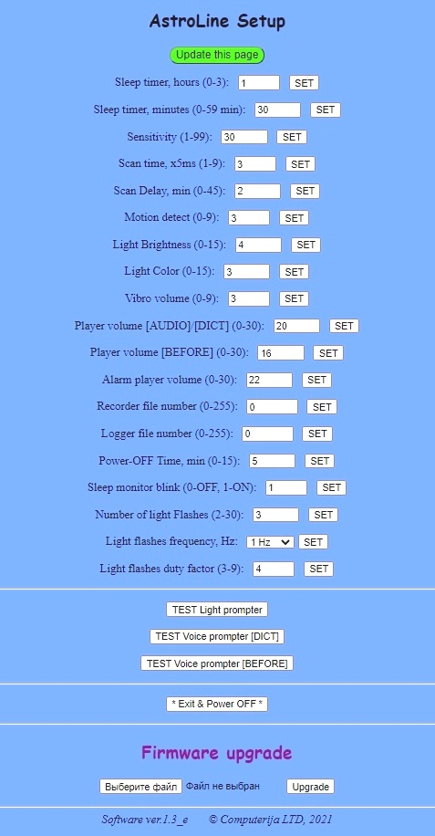

Figure 4. ASTROLINE interface web page view

Software update

The new version of the firmware in the form of a binary file with the *.bin extension must be downloaded to the device disk beforehand. After that you can select it by clicking the Select file button and specifying this file. Loading occurs when you click the Upgrade button. At the same time, this binary file is checked for compatibility with the device.

If the check is successful, the file is written to the internal flash memory of the device and its power is turned off. Further software replacement takes place off-line without establishing a connection.

This requires:

1. Switch on the device.

2. In the main menu select Wi-Fi

If a new firmware has been prepared, the screen will display the following message: Program recording, and the Wi-Fi mode itself will not be enabled and the corresponding ASTROLINE access point will not appear.

The green LED will start blinking first (decryption and preparation of files for replacement), and then the red LED will blink – the program memory will be overwritten.

During these operations, it is unacceptable to perform any actions with the device and turn off its power. After the end of the programming process, the device switches itself off. The programming process can take a relatively long time (3-5 minutes).

After the device turns off after programming, it can be turned on again. In this case, the device will already have a new firmware version. You can view the firmware version through the web interface.

It is displayed at the bottom of the page «Software ver.XX_у», where XX is the current software version, and «y» taking the value «r» or «e» indicates which page is loaded – Russian (r) or English (e).

4. OPERATION IN USB STORAGE MODE

To work with the device as with a USB storage device, you must first connect the USB cable to the device and the computer, while the power of the device must be turned off, and then turn on the power. The device will display:

USB CONN : OK

If the device is successfully recognized by the computer, the device is displayed as AstroLine DISK USB Device on the computer. It is possible to copy files to the memory card, delete them or rename them. The MicroSD card must first be formatted with the FAT32 file system and the standard cluster size (512 bytes).

After completing the work on moving or viewing files and software disconnection from the computer, the device can be physically disconnected from the USB cable. After that, the device will turn itself off.

5. CHARGING THE STORAGE BATTERY

Before starting long-term operation (sleep monitoring), it is recommended to charge the battery if its level is below 30%. The battery level is displayed in the corner of the main menu (see Figure 3).

To do this, you need to connect a wire from a computer or a charger to the USB connector. The charging current provided by the adapter must not be lower than 300 mA.

The device must be turned off while charging the battery!

At the same time, if the charging process takes place, the charge indicator on the front side of the device case glows red. And when the battery is charged, it lights up green. In this case, the device can be disconnected from the charger and used.

Average charging time is 4 - 4.5 hours.

Attachment 1

LOG file form and sleep event analysis

During sleep monitoring with a microSD card inserted, an event report is always generated in the LOG folder as a file with an automatically assigned index. View of the file name LOGxxx.txt, where «xxx» is the index automatically incremented when the file is created and available for editing through the form of the web interface.
Below is an example of a typical LOG file.
04:12 = START
04:14 = EYE MOVE (LR) 021 001
04:19 = EYE MOVE (LR) 016 004
04:22 = EYE MOVE (LR) 017 000
04:27 = EYE MOVE (LR) 037 054
04:29 = EYE MOVE (LR) 032 009
04:32 = EYE MOVE (LR) 038 028
04:36 = EYE MOVE (LR) 073 052
04:43 = EYE MOVE (LR) 042 057
04:51 = EYE MOVE (LR) 021 000
04:56 = EYE MOVE (LR) 019 001
05:09 = EYE MOVE (LR) 020 002
05:09 = HEAD MOVE: RES. PROMPT_1
05:11 = EYE MOVE (LR) 007 016
05:17 = EYE MOVE (LR) 002 016
05:20 = EYE MOVE (LR) 020 006
05:22 = EYE MOVE (LR) 120 023
05:26 = EYE MOVE (LR) 006 016
05:29 = EYE MOVE (LR) 006 016
05:31 = EYE MOVE (LR) 009 053
05:50 = EYE MOVE (LR) 001 018
05:53 = EYE MOVE (LR) 024 069
05:56 = EYE MOVE (LR) 135 030
05:57 = HEAD MOVE: RESET LIGHT
06:00 = EYE MOVE (LR) 004 026
06:02 = EYE MOVE (LR) 016 024
06:05 = EYE MOVE (LR) 026 000
06:07 = EYE MOVE (LR) 017 017
06:10 = EYE MOVE (LR) 016 012
06:21 = EYE MOVE (LR) 017 013
06:24 = EYE MOVE (LR) 002 017
06:26 = EYE MOVE (LR) 018 014
06:26 = HEAD MOVE: RES. PROMPT_2
06:35 = EYE MOVE (LR) 037 015
07:16 = HEAD MOVE
07:19 = EYE MOVE (LR) 007 017
07:24 = EYE MOVE (LR) 016 007
07:27 = EYE MOVE (LR) 017 010
07:27 = HEAD MOVE: RES. PROMPT_2
07:29 = EYE MOVE (LR) 017 006
07:33 = EYE MOVE (LR) 022 006
07:33 = HEAD MOVE: RES. PROMPT_2
07:35 = HEAD MOVE
07:38 = END SLEEP

Consider the mnemonics used in the report:

START – start of monitoring, the time at which the sleep timer ended is marked.

EYE MOVE (LR) – event from eye movement sensors. The intensity of movement corresponding to the left and right eyes is shown.

HEAD MOVE – head movement event.

HEAD MOVE: RES. PROMPT_1 – the movement of the head was at the moment of issuing a voice prompt from the BEFORE folder and the prompt was canceled by this movement.

HEAD MOVE: RESET LIGHT – the movement of the head was at the moment of issuing the light prompt and the prompt was canceled by this movement.

HEAD MOVE: RES. PROMPT_2 – the movement of the head was at the moment of issuing the voice prompt from the DICT folder and the prompt was canceled by this movement.

END SLEEP – end of sleep in time.

It can also be KEY PRESS and END - if sleep monitoring was terminated by pressing the keys.
The presented LOG file shows that the end of sleep was accompanied by frequent head movements, and active sleep was noted between 4:32 am and 5:56 am.

_____________________________________________________

2021

